Experiment 7
program code: DFS

#include <stdio.h>
#include <stdlib.h>

int source, V, E, time, visited[20], G[20][20];
void DFS(int i)
{
int j;
visited[i]=1;
printf("%d->", i+1);
for(j=0;j<V;j++)
{
if(G[i][j] == 1 && visited[j] ==0)
(j);
}
}

int main()
{
int i, j, v1, v2;
printf("\t\t\tGraphs\n");
printf("Enter the no. of edges: ");
scanf("%d", &E);
printf("Enter the no. of vertices");
scanf("%d", &V);
for(i=0;i<V;i++){
for(j=0;j<V;j++)
G[i][j]=0;
}
for(i=0;i<E;i++){
printf("Enter the edges (format: V1 V2): ");
scanf("%d %d", &v1, &v2);
G[v1-1][v2-1] = 1;
}
for(i=0;i<V;i++){
for(j=0;j<V;j++)
printf("%d", G[i][j]);
printf("\n");

}
printf("Enter the source: ");
scanf("%d", &source);
DFS(source-1);
return 0;
}
output:

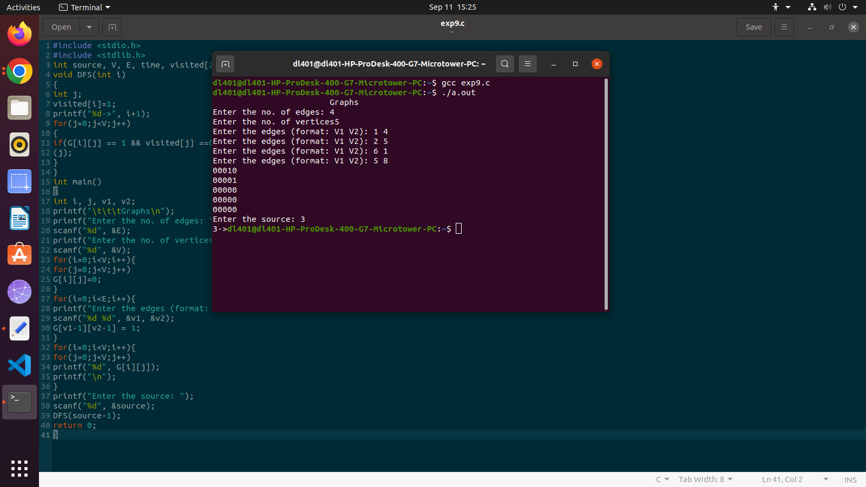

program code:BSF

#include <stdio.h>
#include <stdlib.h>

int a[20][20], q[20], visited[20], n,f =-1, r=-1;
void bfs(int v){
int i;
for(i=0;i<n;i++){
if(a[v][i] != 0 && visited[i] ==0){
r =r+1;
q[r] = i;
visited[i]=1;
printf("%d", i);
}
}
f= f+1;
if(f<=r)
{
bfs(q[f]);
}
}

int main(){
int v, i, j;
printf("\n Enter number of vertices: ");
scanf("%d", &n);
for(i=0;i<n;i++){
visited[i]=0;
printf("\n Enter graph data in matrix form\n");
for(i=0;i<n;i++){
for(j=0;j<n;j++){
scanf("%d", &a[i][j]);
}
}
printf("\n Enter the starting vertex: ");
scanf("%d", &v);
f = r=0;
q[r]=v;
visited[v]=1;
printf("%d", v);
bfs(v);
if(r!=n-1){
printf("\n BFS not possible");
printf("\n");
}
return 0;

}



